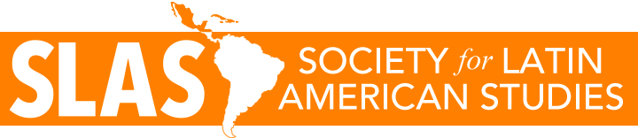
Timeline & checklist for conference organisers
The SLAS conference normally takes place during the Easter break on a Thursday and Friday, and organisation is delegated to a local organising committee.
One of the local conference organisers sits on the SLAS committee in the year leading up to the conference, giving a report at each meeting.

Timeline
June | Set dates for conference & announce these on SLAS website & Twitter.
August | Distribute Call for Papers.
October | Call for Papers closes & decisions processed.
November | Accept/reject e-mails to go out.  Deadlines for SLAS conference Grants.
January | Draft programme published.  Registration opens (normally with early bird discount rate)
February / March | Registration closes & final conference programme published.
March / April | Conference

Checklist
The following checklist is not exhaustive and is only intended as a guide to help conference organisers address some points that have been raised in the past.
- Have you read and followed the SLAS Climate Action Plan (link on SLAS website)?
- Are all rooms (including venue for conference dinner) accessible?
- Have you scheduled the AGM in the programme?
- Have you included details of quiet spaces, baby changing facilities and parenting rooms to delegates?

